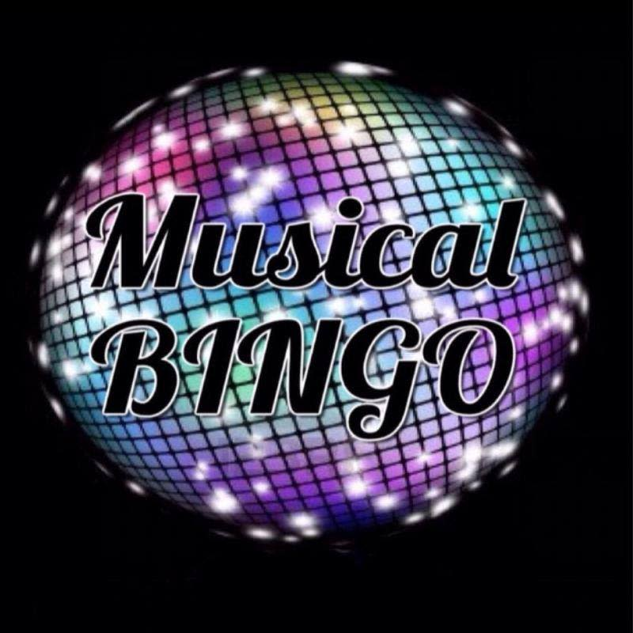
Musical Bingo

Saturday 17th October 2020

Songs/Artists

Old Town Road  I like to move it  Justin Timberlake  Dwayne Johnson  Baby Shark  Cheerleader  Gangnam Style  Under the sea  How far I’ll go  You’ve got a friend in me  Katy Perry  Hugh Jackman  Idina Menzel  One Direction  Macarena  Little Mix  George Ezra  Mamma Mia  Do you wanna build a snowman?  Zac Efron | Kids Bop Shuffle  Bruno Mars/ Mark Ronson  Taylor Swift  Justin Bieber  S Club 7  Shawn Mendes / Camilla Cabello  The Weekend  Walk the Moon  Ariana Grande  Ed Sheeran  Pharell Williams  Jason Derulo  Oasis  Adele  Black Eyed Peas  Steps  Westlife  Spice Girls  Dynamite  Tick Tock | Michael Jackson  Take That  Whitney Houston  Queen  Amy Winehouse  Wham  Elton John  Sam Smith  Miley Cyrus  High School Musical  Imagine Dragon  Elvis Presley  Coldplay  YMCA  Olly Murs  Party Rock Anthem  Conga  Cha Cha Slide  All Star  Dance Monkey

